**ASSIGNMENT 2 - AGGREGATION EXERCISE**

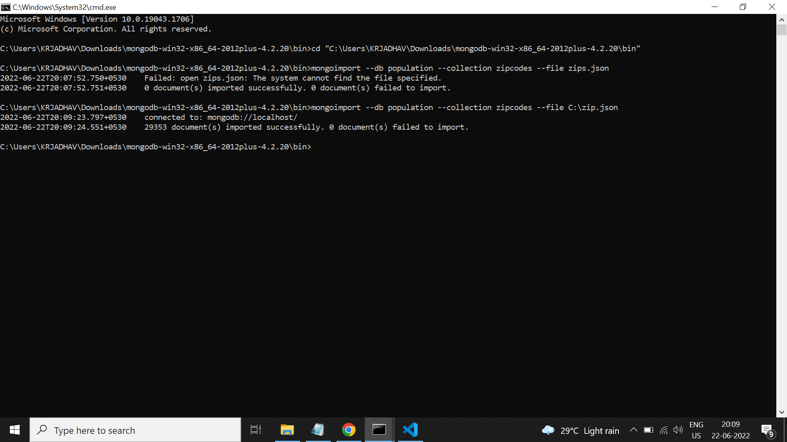

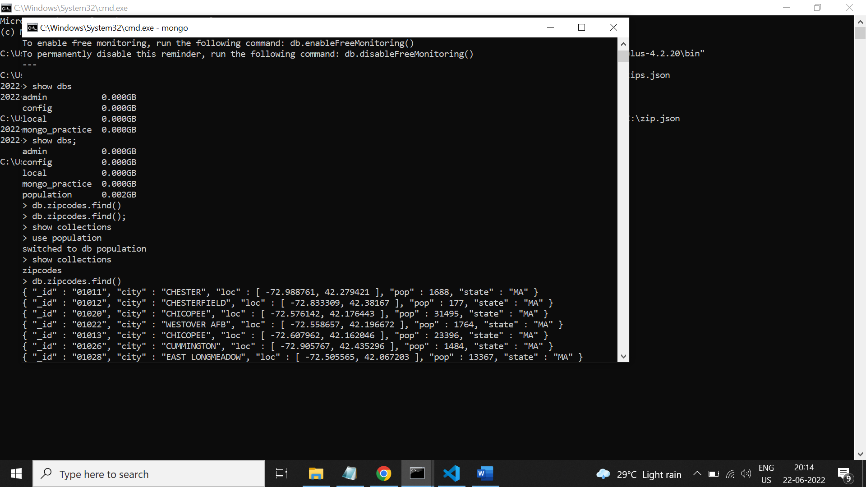

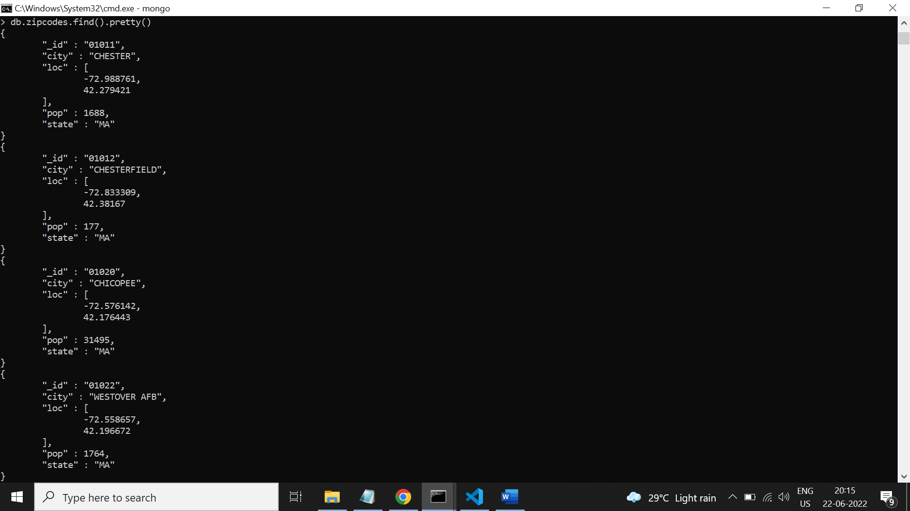

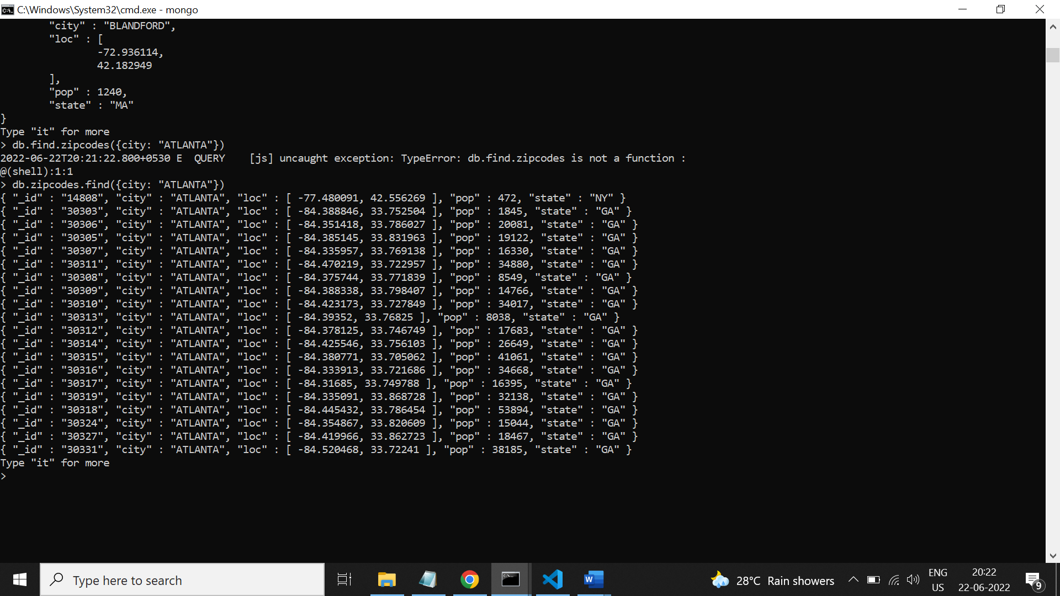

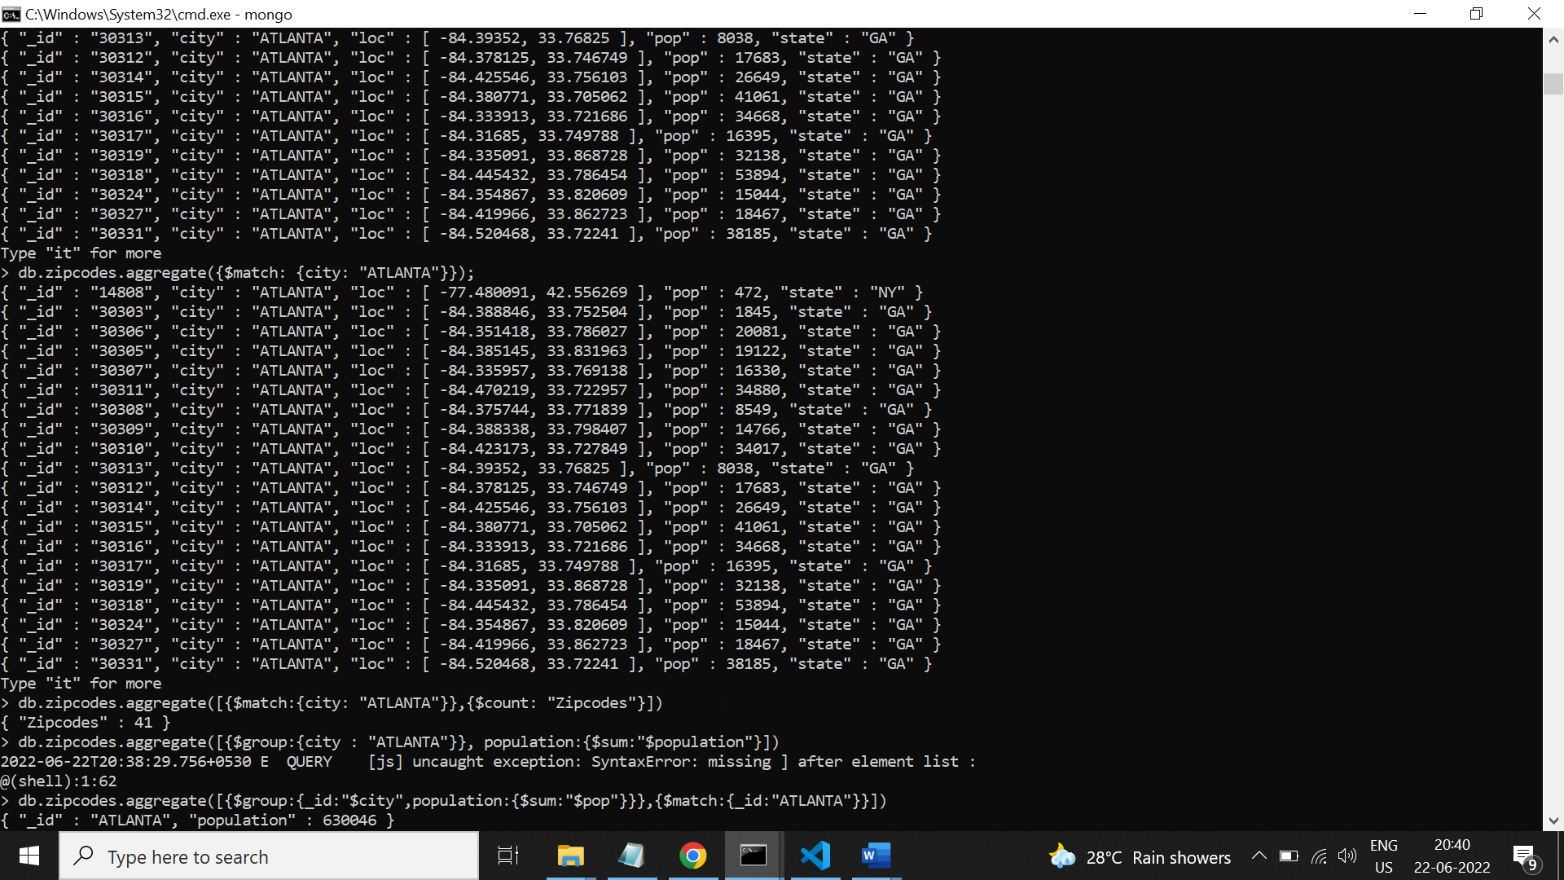

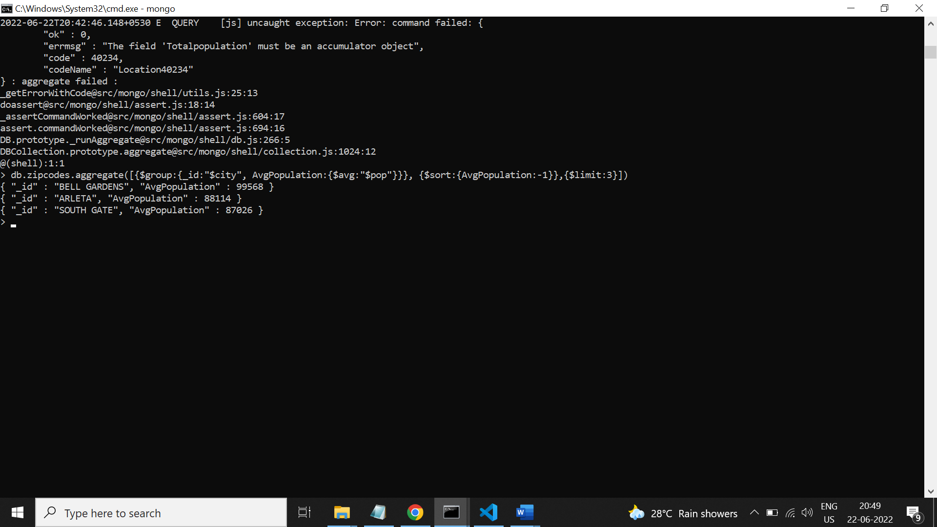

**ASSIGNMENT 3 - AGGREGATION EXERCISE**

